**The** 12**th China International Rescue & Salvage Hotel arrangement-LiYuan Grand Metro Park Hotel NanNing**

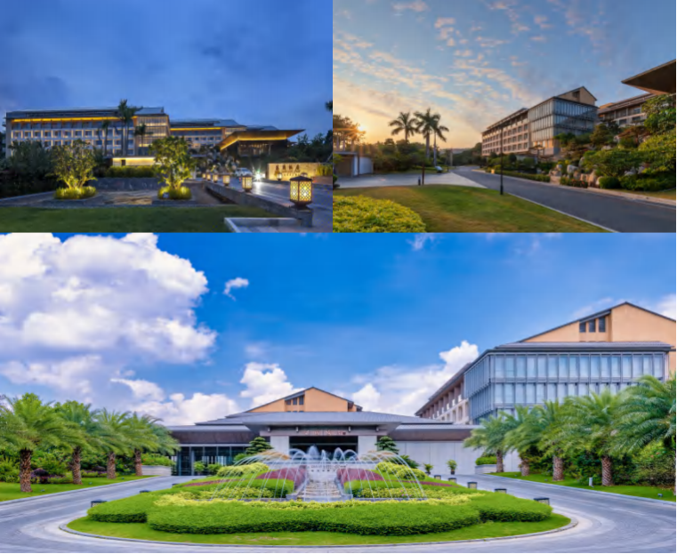

**"The Salvage and Rescue Committee of the Chinese Institute of Navigation will hold the 12th China International Salvage & Rescue Forum in Nanning, Guangxi, from May 22 to 23, 2025."**

**LiYuan Grand Metro Park Hotel NanNing Located in the heart of Nanning, the vibrant capital of Guangxi Zhuang Autonomous Region,  Nanning Liyuan Grand Metropark Hotel is nestled amidst verdant mountains and overlooks the picturesque views of Nanning Bridge and the Yong River.Nanning Liyuan Grand Metropark Hotel boasts a banquet hall capable of accommodating nearly 1,000 guests and uniquely designed meeting rooms, catering to diverse conference and banquet requirements.Attentive butler services and meticulous care ensure a warm, home-like stay.**

**Hotel address：**

**· No. 2, Libin Avenue, Qingxiu District, Nanning City, Guangxi china (near Nanning Bridge)**

**Traffic guide：**

**· 1、Nanning Wuxu International Airport → Approximately 40 minutes by car (The hotel provides direct Airport Shuttle Bus Line 5)**

**· 2、Nanning East Station (High-speed Rail Station) → About 20 minutes by car**